Please mark your calendars and plan to join us for the Blessing of the Seed
Sunday, June 2 at 3:00 pm in the Growing Fields,
11720 Wolfsville Road, Myersville, MD.

Celebrate the anticipation as we begin our 19th year working to
reduce world hunger with this year’s program in
Paraguay Lower Chaco
All are welcome
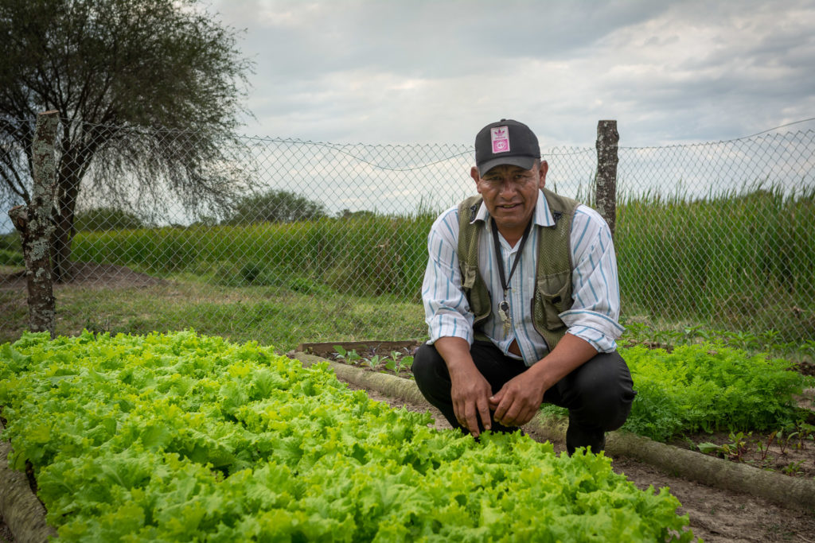

About the Paraguay Lower Chaco Program

The Gran Chaco region is an immense and little-heard-of region in the heart of South America. It is the biggest forest reserve on the continent after the Amazon and one of the largest dry forests in the world.
The purpose of this three‐year program is to partner with 588 families (approximately 2,200 people) in six indigenous communities (16 villages) of the Paraguayan Chaco region of South America to create durable improvements in the areas of access to water, food security, community development and organization. The program provides culturally‐sensitive technical assistance in family and community farming and livestock, community capacity‐building and supporting indigenous‐led advocacy.
“Field of Hope”
Growing Hope Globally
Sponsor Form

I/We will sponsor acres at the donation rate
of $250 per acre (1/2 acre $125, ¼ acre $62.50).

Persons sharing in sponsorship:

Total pledge $

All pledges due by October 30, 2024.
Please make checks payable to Grossnickle Church
of the Brethren, designated “Field of Hope.”
Signature

Participants
Beaver Creek Church of the Brethren
Christ Reformed United Church of Christ
Edgewood Church of the Brethren
Grossnickle Church of the Brethren
Hagerstown Church of the Brethren
Harmony Church of the Brethren
Manor Church of the Brethren
Pastorate of St. Francis, St. Mary and Holy Family
Third Street Church of God (Washington, D.C.)
Welty Church of the Brethren
Catholic Daughters Court Mary Francis
Catholic Daughters Court Hagerstown
Knights of Columbus, Seton Chapter

Our thanks to Donnie and Donna Grossnickle, farmers

